Name:  Class: | ____________________________________  ________________ | Date:_________
 | Year 9 Mathematics 2018  / 20  STEM Investigation  Energy Use Around the Home  Collaborative Component

This investigation will examine the use of energy around the home. The four main uses of energy in Australian homes are:
- Heating and cooling (40%)
- Appliances (33%)
- Water heating, (20%) and
- Lighting (6%)

Understanding where you use the most energy can help you manage energy costs and it can be beneficial to the environment.

Question 1: Measuring Energy Consumption 9 marks
Electrical appliances require different amounts of power to operate. We can think of power as the measurement for the instantaneous energy usage of an appliance. Energy used around the home is measured in kilowatt hours, (kWh), by the electricity provider. In Perth, the electricity provider is Synergy.

Energy used around the home is calculated by the following formula:
$$Energy=Power×Time$$
Power is in kilowatts, (kW)
Time is measured in hours, (h)

All appliances around the home have a power rating in watts, (W). There are 1000 watts in a kilowatt. Complete the following table by calculating the energy consumed by the appliances and the total energy used daily.

Appliance | Power on appliance  (P) | Estimated time used daily (h) | Energy consumed daily (kWh)
Television | 320 W  = _______ kW | 2
Fridge | 150 W  = ________ kW | 24
Washing Machine | 700 W  = _______ kW | 2
Laptop | 100 W  = ______ kW | 4
 |  | Total

Question 2: Cost of Electricity 6 marks
Synergy charges 24.0673 cents for every kilowatt hour of energy used around the home. The billing period for most Perth homes is 63 days.

- Using your answer from the previous question determine the cost of running the appliances for a billing period.
- This is a bill from Synergy for a 3 bedroom, 2 bathroom house. Fill in the missing values.
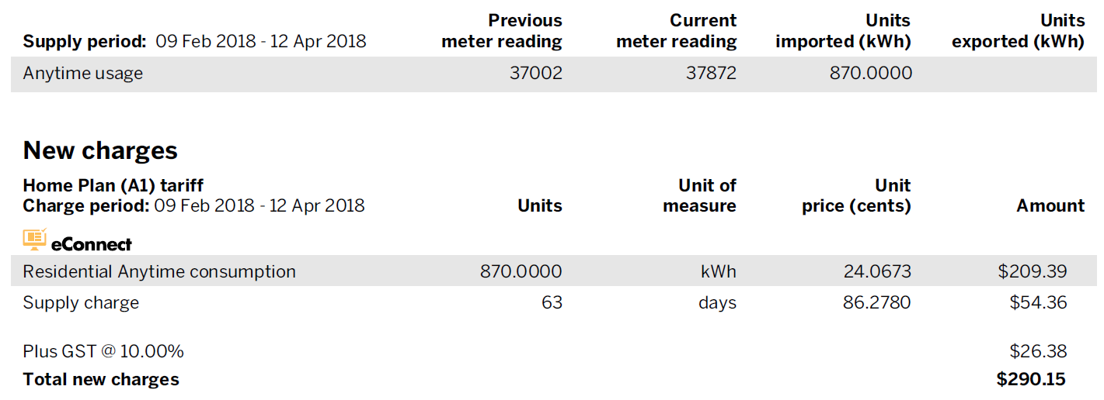

Question 3: Solar Panels 5 marks
People throughout Australia are installing solar panels on the roofs of their homes to reduce their energy bills. The best technology on the market currently are solar panels made of crystalline silicon. These solar panels have a length of 155.8 cm and a width of 104.6 cm and have a power rating of 327 W.

- Solar panels are arranged on roofs next to each other when they are installed. They are called arrays. Most homes area installing arrays made of 15 solar panels. What power rating would an array of 15 solar panels have? Provide your answer in kW.
- How much area of the roof would an array of this size cover?
- If the average Australian house has a roof surface area of 600 m². What is the ratio of the area of the solar array to that of the roof?

